表格一  Form ( 1 ) | 標準展位位置圖  Booth Layout (Shell Scheme) | 請電郵或傳真回Please return to:  廣告天地有限公司  Creation Advertising Co., Ltd.  地址:澳門士多紐拜斯大馬路63B - 65 A地下  Address: Av. Sidónio Pais No.63B-65A R/C, Macau  電話Tel: +853-2897 6198 / +853-2897 6199  傳真Fax: +853-2897 6197  電郵Email: sales@creation.com.mo
截止日期  Deadline  28 February 2019 | 標準展位位置圖  Booth Layout (Shell Scheme)

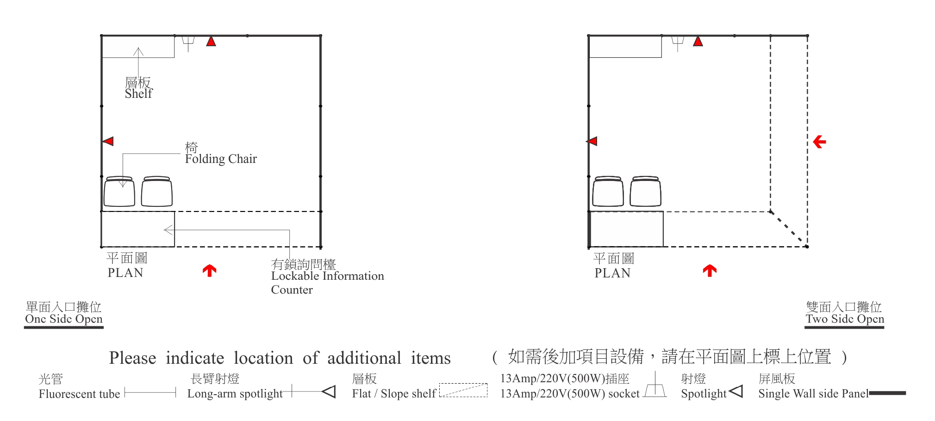
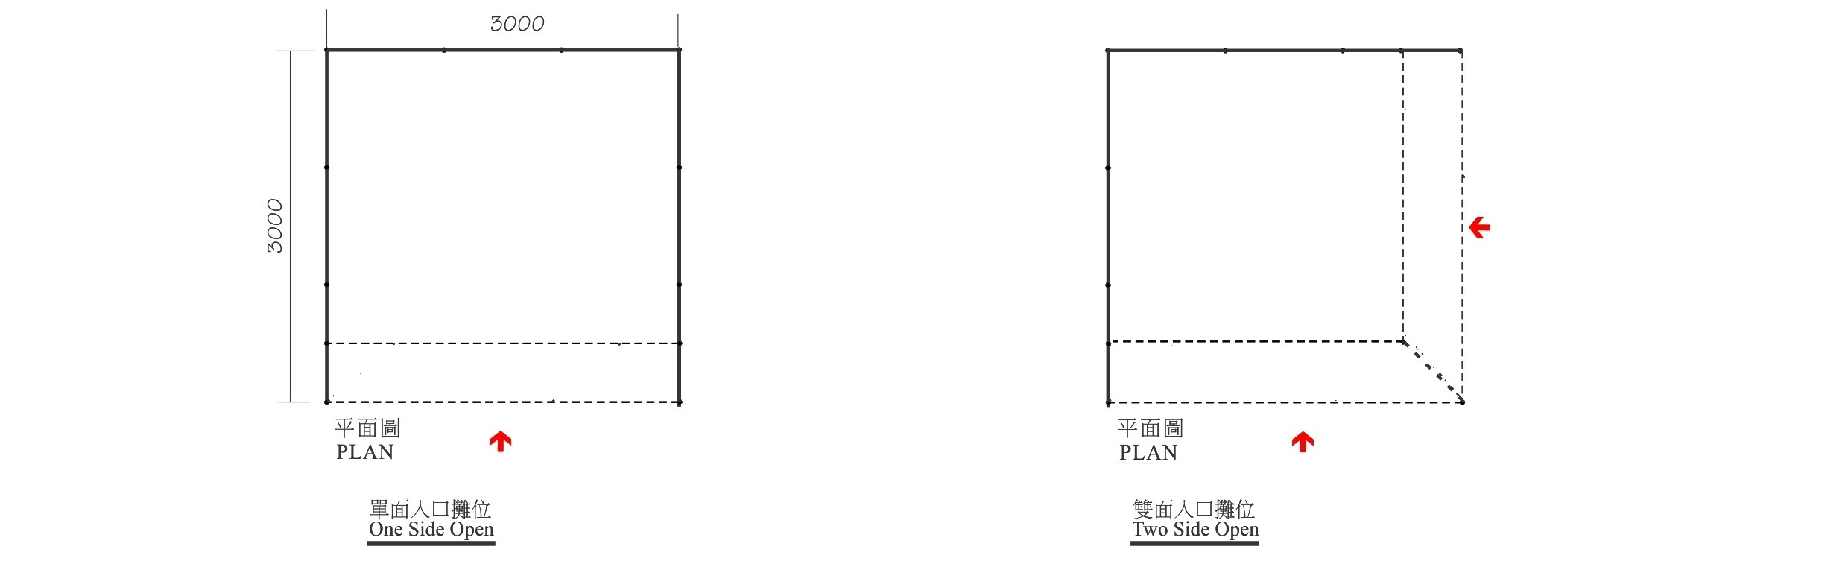

備註：請把電力裝置及層板等之位置標示於上列位置圖上，若參展商未能提交此圖，標準展位承建商將會在適當位置代為安裝；如須現場更改位置或取消須另行繳費，電力裝置每個項目澳門幣150.00，層板每個項目澳門幣100.00。
Remark: Exhibitors are requested to mark on the plan above the position of their electrical requirements. Standard booth contractor will install at our discretion if we do not receive any instruction before move in. Requests for removal and dismantling of socket/spotlight on-site will be charged MOP150.00 per one. Requests for removal and dismantling shelves on-site will be charged MOP100.00 per one.
申 請 公 司 EXHIBITOR’S AUTHORISATION
公司  Company: | 展位號碼  Booth No.:
聯絡人  Contact Person: | 職位  Job Title:
電話  Tel: | 傳真  Fax:
電郵
Email:
簽署及蓋章  Signature & Company Chop: | 日期  Date:

標準展位設計  Shell Scheme Booth Design | 綠色建築展位設計  Green Building Pavilion Scheme Booth Design
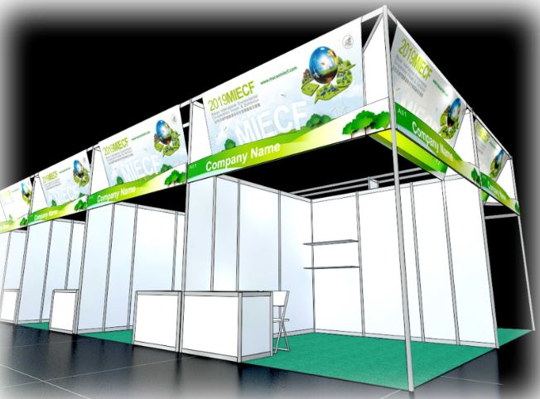 | 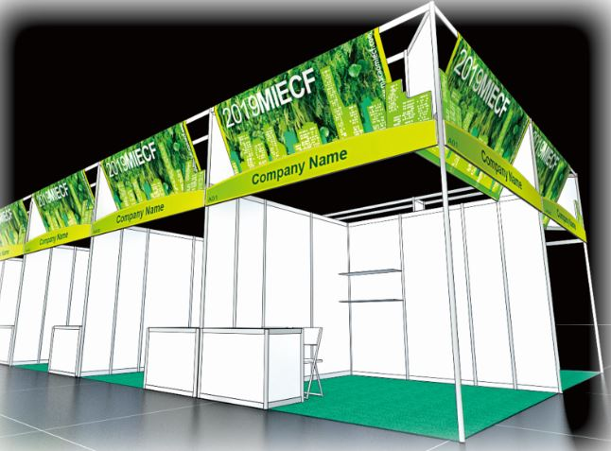
循環經濟展位設計
Circular Economy Booth Design
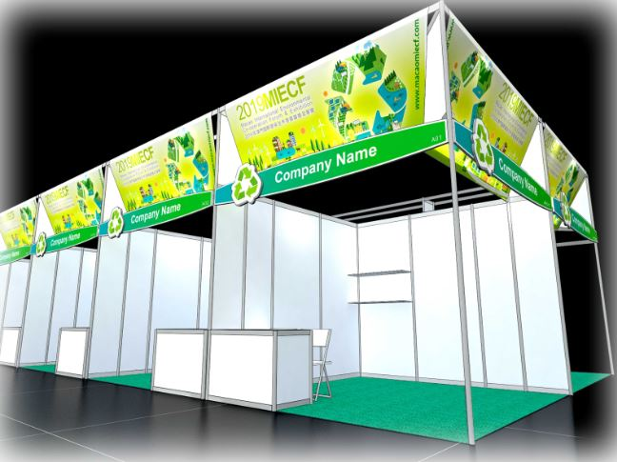
每組展位設備包括 (以9㎡ 計算) Each shell scheme booth will include (Based on 9sqm):
標準展位圍板 | Standard shell scheme system panels
公司眉板1件 | Fascia board x 1 no
頂架裝飾1組 | Roofing structure x 1 no
有鎖詢問枱1張配2椅 | Lockable Information counter with 2 chairs
層板2件 | Shelves x 2 nos
9平方米環保地毯 | 9 sqm Recycled carpet
23W節能射燈2支 | 23W Energy Saving Spotlight x 2 nos
13Amp/220V(500W)插座1個 | 13Amp/220V (500W) Socket x 1 no
表格一  Form ( 1 ) | 標準展位位置圖  Booth Layout (Shell Scheme) | 請電郵或傳真回Please return to:  廣告天地有限公司  Creation Advertising Co., Ltd.  地址:澳門士多紐拜斯大馬路63B - 65 A地下  Address: Av. Sidónio Pais No.63B-65A R/C, Macau  電話Tel: +853-2897 6198 / +853-2897 6199  傳真Fax: +853-2897 6197  電郵Email: sales@creation.com.mo
截止日期  Deadline  28 February 2019 | 標準展位位置圖  Booth Layout (Shell Scheme)

