NO. | ITEMS | Rental Prices |  | Rental Prices |  | Rental Prices |  | Qty. | Amount
NO. | ITEMS | ( MOP ) |  | ( HKD ) |  | ( USD ) |  | Qty. | (MOP/HKD/USD)
FW01 | Information Counter 950mm (W) × 500mm (D) × 800mm (H) | 280.00 |  | 272.00 |  | 36.00
FW02 | Lockable Information Counter 950mm (W) × 500mm (D) × 800mm (H) | 340.00 |  | 330.00 |  | 43.00
FW03 | Round Table Ø60cm × 680mm (H) | 180.00 |  | 175.00 |  | 23.00
FW04 | Square Table 600mm(W) × 600mm (D) × 740mm (H) | 310.00 |  | 301.00 |  | 39.00
FW05 | Round Conference Table in Gray Ø90cm × 770mm (H) | 310.00 |  | 301.00 |  | 39.00
FW06 | Information Counter with Green Skirting 1800mm(W) × 750mm(D) ×  750mm (H) | 350.00 |  | 340.00 |  | 44.00
FW07 | Cabinet 1000mm(W) ×500mm(D) × 750mm (H) | 500.00 |  | 486.00 |  | 63.00
FW08 | Gray Folding Chair | 80.00 |  | 78.00 |  | 10.00
FW09 | Armchair in Red | 210.00 |  | 204.00 |  | 27.00
FW10 | Chair in Gray | 210.00 |  | 204.00 |  | 27.00
FW11 | Bar Stool –A | 260.00 |  | 253.00 |  | 33.00
FW12 | Bar Stool –B (Black/ White) | 290.00 |  | 282.00 |  | 37.00
FW13 | Guest Chair with Cover (Creamy) | 230.00 |  | 224.00 |  | 29.00
FW14 | Two-Seat Sofa (Pink) 1300mm(W) × 600mm(D) | 485.00 |  | 471.00 |  | 61.00
FW15 | Two-Seat Leather Sofa 1350mm(W) × 520mm(D) | 970.00 |  | 942.00 |  | 122.00
FW16 | Three-Seat Leather Sofa 2000mm(W) × 750mm(D) | 1,295.00 |  | 1,258.00 |  | 163.00
FW17 | Shelf-Flat/Slope 1000mm(W) × 300mm (D) | 160.00 |  | 156.00 |  | 21.00
FW18 | Low Showcase (w/o lighting) 1000mm(W) × 500mm (D) ×950mm(H) | 715.00 |  | 695.00 |  | 90.00
FW19 | Tall Showcase (w/o lighting) 960mm(W) × 460mm (D) × 2500mm (H) | 1,620.00 |  | 1,573.00 |  | 204.00
FW20 | Single wall side panel 1000mm (W) × 2500mm (H) | 130.00 |  | 127.00 |  | 17.00
FW21 | Plant 1000mm(H) | 160.00 |  | 156.00 |  | 21.00
FW22 | Magazine Rack | 260.00 |  | 253.00 |  | 33.00
FW23 | Rubbish Bin | 20.00 |  | 20.00 |  | 3.00
FW24 | Clothes Rod (Length:1000mm) | 80.00 |  | 78.00 |  | 10.00
FW25 | Clothes Hanger | 160.00 |  | 156.00 |  | 21.00
FW26 | 3m (W) × 2.5m(H) PVC material poster on backdrop (Output file provided by the customer) | 3,000.00 |  | 2,913.00 |  | 378.00
FW27 | Design and 2 times modification on 3m (W) × 2.5m(H) backdrop poster | 2,000.00 |  | 1,942.00 |  | 253.00
Onsite Modification Of Standard Facilities
- Dismantling panel (including re-laying of electrical wiring).: MOP195.00 per panel
- Changing panels to open side (including re-laying of electrical wiring and one no. of Fascia board without color background
and lettering.) : MOP240.00 per panel
- Changing open side to 3 nos. of panel.(including re-laying of electrical wiring) : MOP240.00 per panel
- Charged for lettering (Max. 30 characters) for the Fascia board. : MOP240 per panel
- Removal or dismantling of shelves : MOP100.00 per shelf
- Removal or dismantling socket/spotlight : MOP150.00 per piece
 | 30% surcharge for late pre each order received after 1 March 2019
 | 50% surcharge for late order received after 8 March 2019
 | TOTAL
Form ( 3 ) | Furniture Items Rental  (For Standard Booth use only) | Please return to:  Creation Advertising Co., Ltd.  Av. Sidónio Pais No.63B-65A R/C,Macau  Tel：+853-28976198 / +853-28976199  Fax：+853-28976197  E-mail：sales@creation.com.mo
Deadline  28 February 2019 | Furniture Items Rental  (For Standard Booth use only)

*For any other special need of facilities, please contact standard booth contractor for quotations*

EXHIBITOR’S AUTHORIZATION
Company： Name： Job Title： Booth No.：
Tel： Fax： Email：
Signature & Company Chop Payment：MOP /HKD/ USD
Confirmed By Creation ( Official use only )
Date： Signature：
Remarks:
1. FW01–FW27of the above are applicable to Standard Booth only.
2. The above rental fee is entitled 3 show days.
3. The application form must be submitted along with the payment form below, all payments (including surcharges) and the booth facilities layout should be submitted to the standard booth contractor for approval; otherwise application will not be entertained.
4. This application form will be also served as the receipt. Unless requested by exhibitors, no invoice or receipt will be issued separately.
5. All items are on rental basis. In the event of any loss or damage to the rental items for which hirer is liable, the hirer will reimburse the Official Stand Contractor for the total cost of making good or replacement.
6. Please refer to exhibitor manual for photos of rental equipment.
7. 30% surcharge will be charged for any late orders received on or after 1 March 2019. Orders received after 8 March 2019 will be subject to a 50% surcharge. Cancellation after 1 March 2019 is subject to a 30% cancellation charge. Written application is required for the cancellation of orders. No cancellation will be accepted on or after 8 March 2019.
Payment method (Please tick the appropriate box.)
□ Remittance or T/T Payment directly to the following account.
A/C Name：Creation Advertising Co., Ltd.
Bank：Bank of China Macau Branch (Nga Lim Fong Sub-Branch)
A/C No.：18-17-01-20-014957-8 (MOP)
18-17-11-20-020890-6 (HKD/USD)
Swift Code： BKCHMOMX
Address of receiving Bank：No. 20, Avenida do Ouvidor Arriaga, Macau

Note: All banking charges, if any, are to be paid by the applicant.
Please send the remittance receipt back to Creation Advertising's accounting department via fax
(853-2897 6197) or e-mail (offcon@macau.ctm.net).
Please mark your company name and booth number on the receipt.

□ Paid by cheque (Only MOP cheques will be accepted)
Payable to：Creation Advertising Co., Ltd.
Cheque No.：____________________________Bank：_____________________________
Amount： (MOP) ___________________________________
Please indicate the show name, company name and your booth no. on the back of the cheque.

Reference photos of additional Furniture (partial)

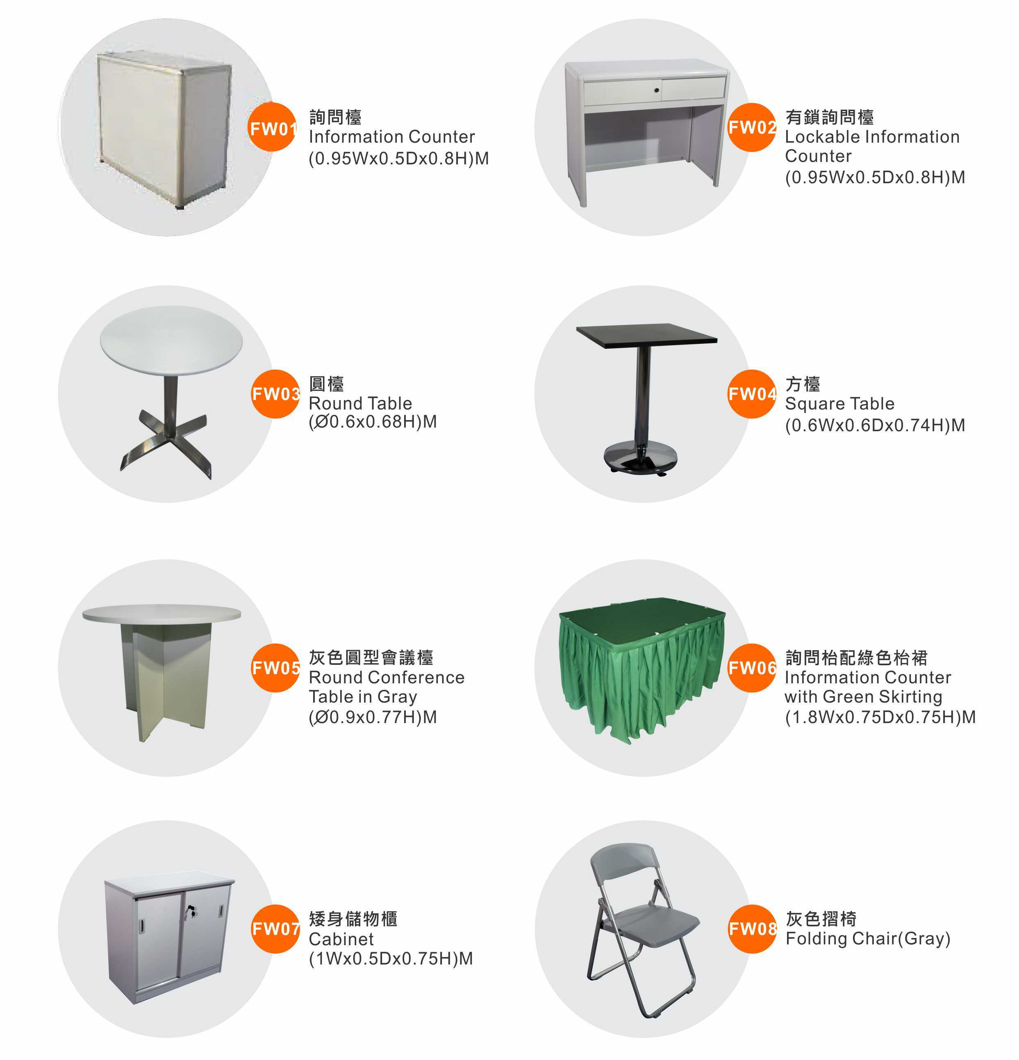

Reference photos of additional Furniture (partial)

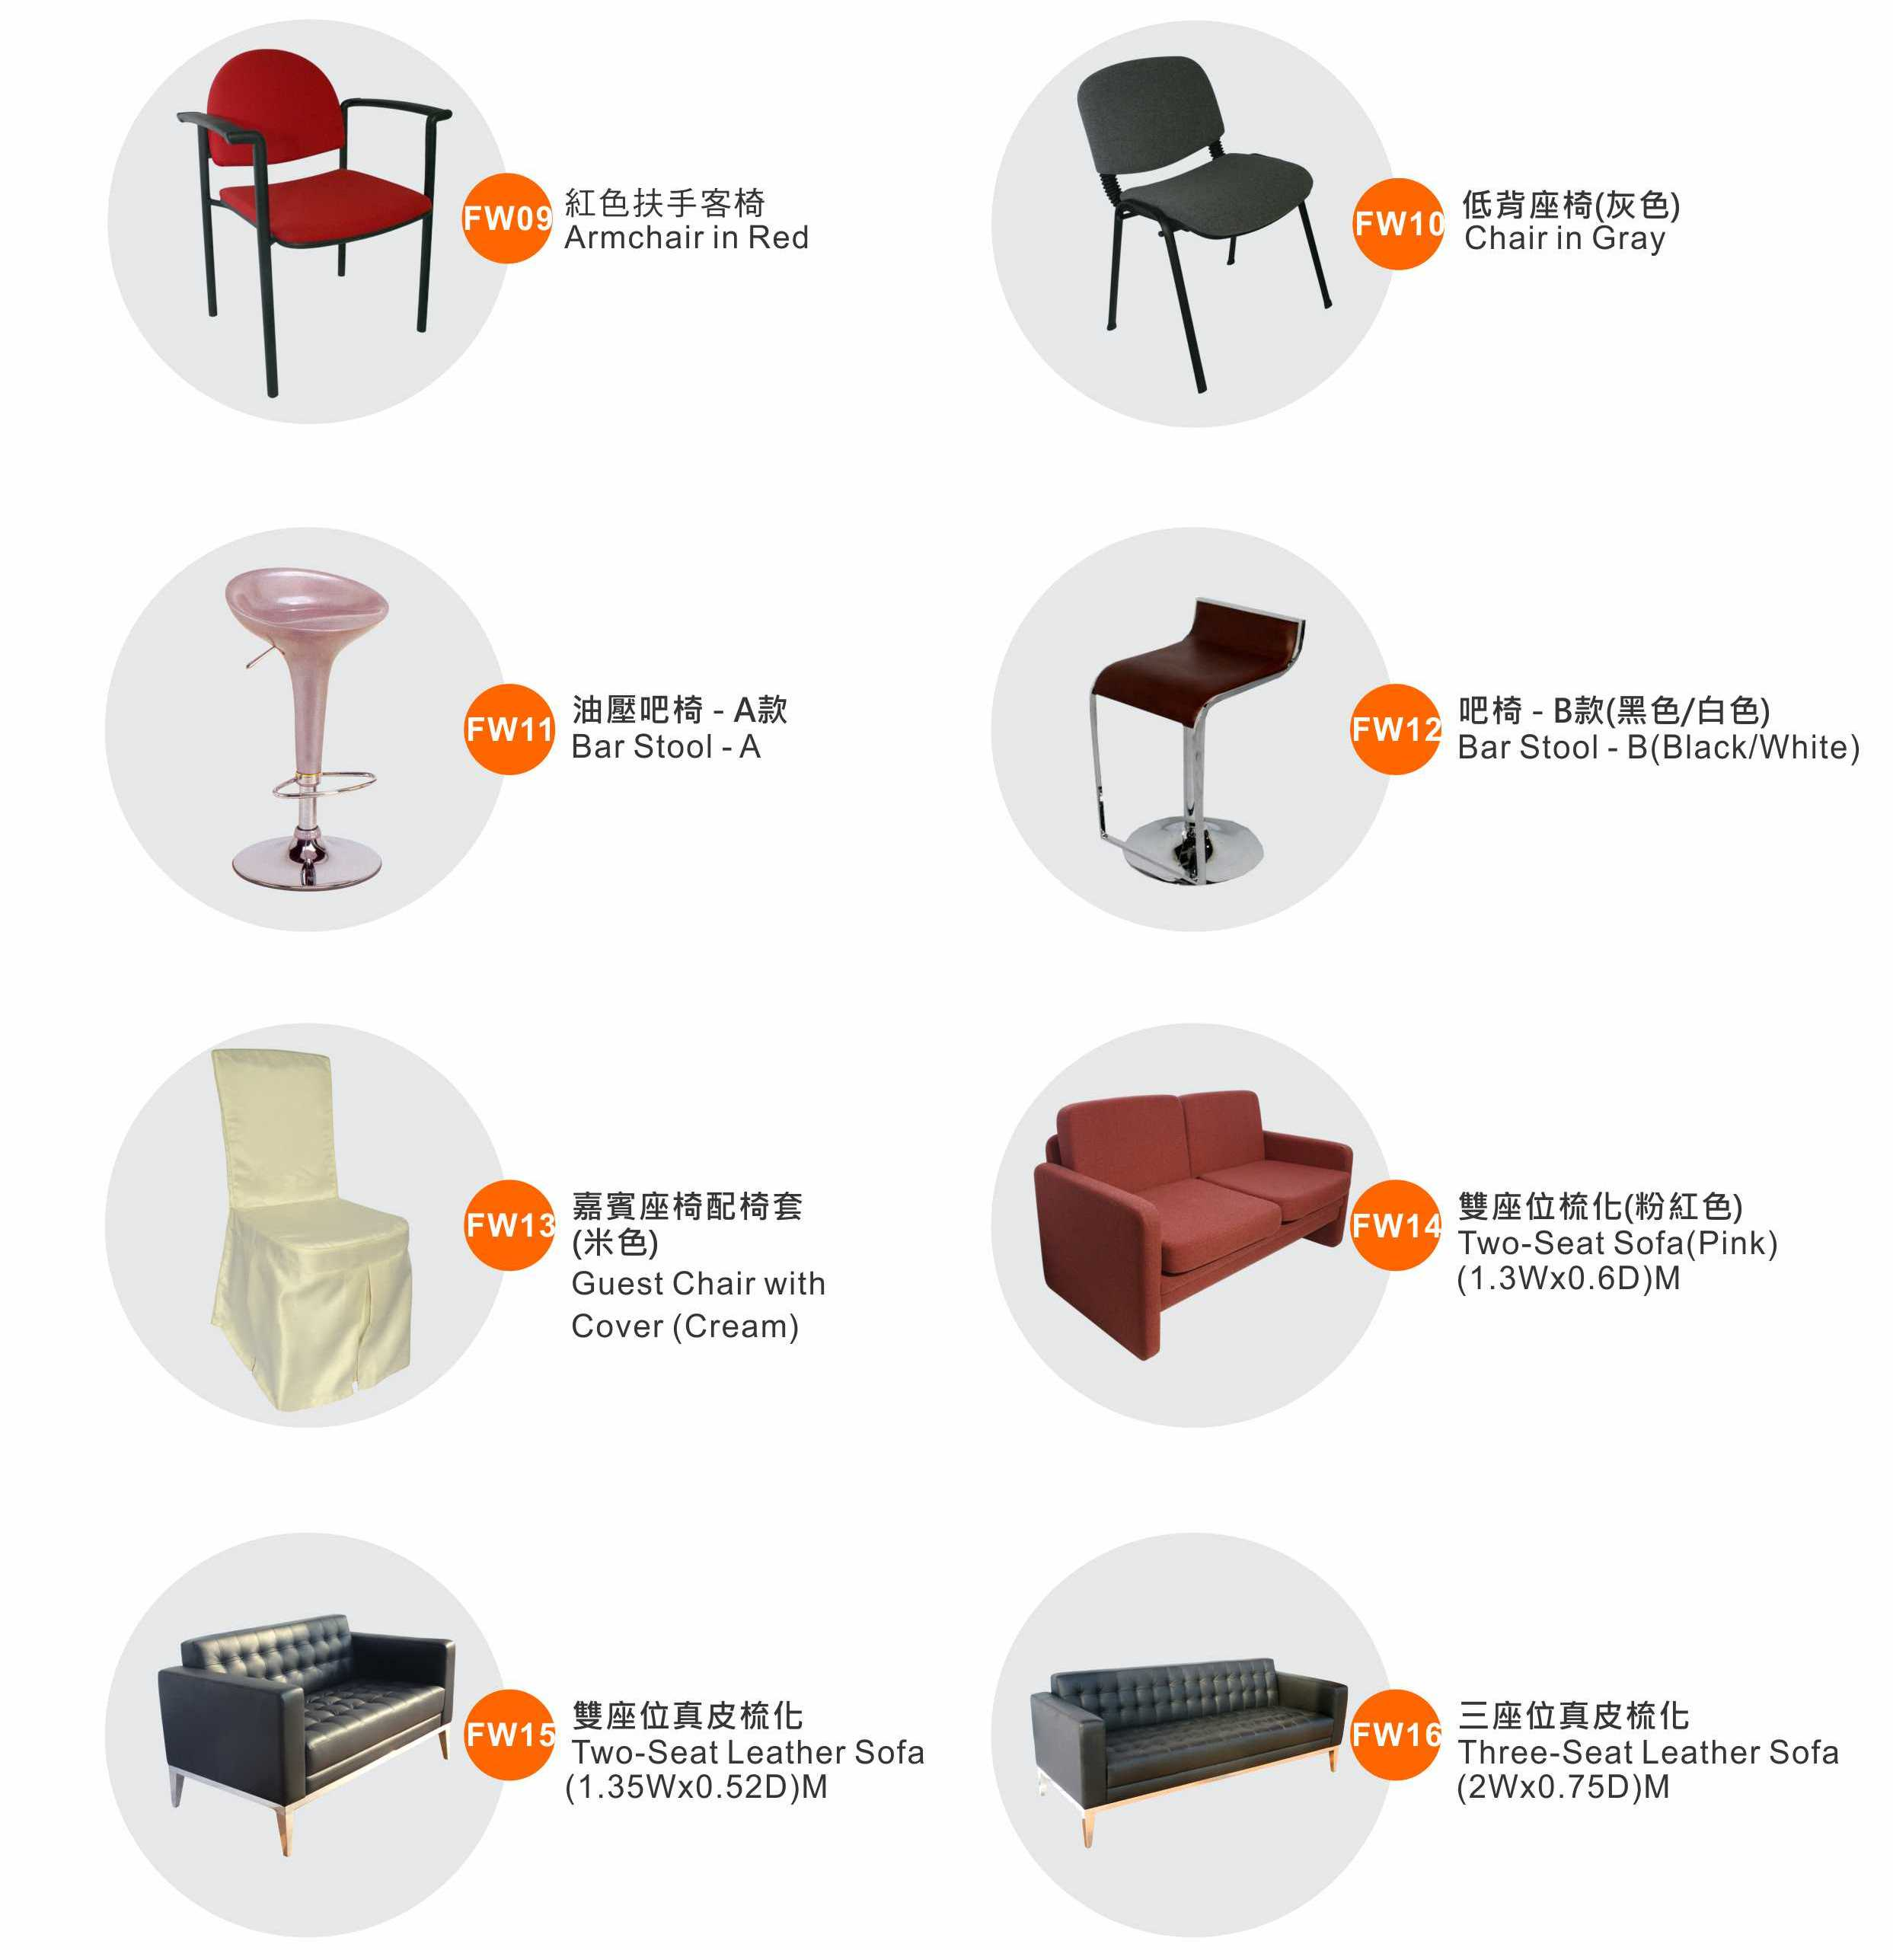

Reference photos of additional Furniture (partial)
