Form ( 4 ) | Electrical Items Rental | Please return to:  Creation Advertising Co., Ltd.  Av. Sidónio Pais No.63B-65A R/C,Macau  Tel：+853-28976198 / +853-28976199  Fax：+853-28976197  Email.：sales@creation.com.mo
Deadline  28 February 2019 | Electrical Items Rental

NO. | ITEMS | Rental Prices |  | Rental Prices |  | Rental Prices |  |  | Qty |  | Amount
NO. | ITEMS | ( MOP ) |  | ( HKD ) |  | ( USD ) |  |  |  |  | (MOP/HKD/USD)
E- 01 | Energy Saving Spotlight 23W (Emitting the same light as an 100W incandescent bulb) | 235.00 |  | 229.00 |  |  | 30.00
E-02 | Energy Saving Long-arm Spotlight 23W(Emitting the same light as an 100W incandescent bulb) | 250.00 |  | 243.00 |  |  | 32.00
E-03 | Energy Saving Fluorescent Tube 28W (Emitting the same light as an 40W fluorescent tube) | 245.00 |  | 238.00 |  |  | 31.00
E-04 | Halogen floodlight (300W) | 575.00 |  | 559.00 |  |  | 73.00
E-05 | Halogen floodlight (500W) | 655.00 |  | 636.00 |  |  | 83.00
E-06 | Lighting Connection Max. 100W Per Point | 180.00 |  | 175.00 |  |  | 23.00
E-07 | Lighting Connection Max. 200W Per Point | 225.00 |  | 219.00 |  |  | 29.00
E-08 | Lighting Connection Max. 300W Per Point | 295.00 |  | 287.00 |  |  | 38.00
E-09 | Lighting Connection Max. 500W Per Point | 450.00 |  | 437.00 |  |  | 57.00
E-10 | 42” /37” LCD TV with DVD ( Excluding Socket ) | 3,000.00 |  | 2,913.00 |  |  | 378.00
E-10A | TV wall mount | 1,000.00 |  | 971.00 |  |  | 127.00
E-10B | TV stand | 800.00 |  | 777.00 |  |  | 101.00
E-11 | Sitting Style Refrigerator (-18℃, Excluding Socket)  (1280mmW × 570mmD × 915mmH) | 2,000.00 |  | 1,942.00 |  |  | 252.00
E-12 | 1000W Single Phase Socket (@max.1000W,for Machine Only)  (Cannot be used for Lighting) | 565.00 |  | 549.00 |  |  | 72.00
E-13 | 1500W Single Phase Socket (@max.1500W,for Machine Only)  (Cannot be used for Lighting) | 900.00 |  | 874.00 |  |  | 114.00
E-14 | 2000W Single Phase Socket (@max.2000W,for Machine Only)  (Cannot be used for Lighting) | 1,170.00 |  | 1,136.00 |  |  | 148.00
E-15 | 2500W Single Phase Socket (@max.2500W,for Machine Only)  (Cannot be used for Lighting) | 1,440.00 |  | 1,399.00 |  |  | 182.00
E-16 | 3000W Single Phase Socket (@max.3000W,for Machine Only)  (Cannot be used for Lighting) | 1,620.00 |  | 1,573.00 |  |  | 204.00
E-17 | Power Main- 30AMP/220V( @max. 5000W,for Machine Only )  (Cannot be used for Lighting) | 3,240.00 |  | 3,146.00 |  |  | 408.00
E-01 – E-17 of the above are applicable to Standard Booth only.
E-18 | Socket 2000W (220V) (for lighting only) | 3,150.00 |  | 3,058.00 |  |  | 396.20
E-19 | Power Main- 30AMP/220V( for Lighting only) | 6,750.00 |  | 6,553.00 |  |  | 849.10
E-20 | Power Main-30AMP/380V(for Lighting only) | 13,500.00 |  | 13,107.00 |  |  | 1,698.10
E-21 | Power Main-60AMP/380V(for Lighting only) | 27,000.00 |  | 26,214.00 |  |  | 3,396.20
E-22 | Socket 1000W(220V) for 24 hours | 2,100.00 |  | 2,039.00 |  |  | 265.00
E-23 | Socket 2000W(220V) for 24 hours | 3,900.00 |  | 3,787.00 |  |  | 491.00
E-24 | Socket 3000W(220V) for 24 hours | 5,700.00 |  | 5,534.00 |  |  | 717.00
 | 30% surcharge for late order received after 1 March 2019
 | 50% surcharge for late order received after 8 March 2019
 |  |  | TOTAL

* For other electrical fittings that are not listed in the table above, please contact the standard booth contractor for quotations.
EXHIBITOR’S AUTHORIZATION
Name： Job Title： Booth No.：
Company：
Tel： Fax： Email：
Signature & Company Chop Payment： MOP /HKD/ USD

Confirmed By Creation( Official use only )

Date： Signature：

Remarks:
- The application form must be submitted along with the payment form below, all payments (including surcharges) and the booth facilities layout should be submitted to the standard booth contractor for approval; otherwise application would not be entertained.
- The about rental fee is entitled 3 show days.
- This application form will be also served as the receipt. Unless requested by exhibitors, no invoice or receipt will be issued separately.
- All items are on rental basis. In the event of any loss or damage to the rental items for which hirer is liable, the hirer will reimburse the standard booth contractor for the total cost of making good or replacement.
- 30% surcharge will be charged for any late orders received on or after 1 March 2019. Orders received after 8 March 2019 will be subject to a 50% surcharge.
- Cancellation after 1 March 2019 is subject to a 30% cancellation charge. Written application is required for the cancellation of orders. No cancellation will be accepted on or after 8 March 2019.
- All rental sockets are for electrical appliances only. Exhibitor or their contractor must pay the light wiring fee for any self-prepared lighting devices setup. Light wiring and lighting set up must be approved by the official contractor in advance. Exhibitor will be charged a 100% administration fee for suspension of electricity to their booth or to the entire venue when self-connection of lighting devices to electric socket.
- Each electric socket shall be used for one electrical appliance only. Use of extension cord is prohibited.

Payment method (Please tick the appropriate box.)
□ Remittance or T/T Payment directly to the following account.
A/C Name：Creation Advertising Co., Ltd.
Bank：Bank of China Macau Branch (Nga Lim Fong Sub-Branch)
A/C No.：18-17-01-20-014957-8 (MOP)
18-17-11-20-020890-6 (HKD/USD)
Swift Code：BKCHMOMX
Address of receiving Bank：No. 20, Avenida do Ouvidor Arriaga, Macau

Note: All banking charges, if any, are to be paid by the applicant.
Please send the remittance receipt back to Creation Advertising's accounting department via fax
(853-2897 6197) or email (offcon@macau.ctm.net).
Please mark your company name and booth no. on the receipt.

□ Paid by cheque (Only MOP cheques will be accepted)
Payable to：Creation Advertising Co., Ltd.
Cheque No.：____________________________Bank：_____________________________
Amount： (MOP) ___________________________________
Please indicate the show name, company name and your booth no. on the back of the cheque.

Reference photos for additional electricity installation (partial)

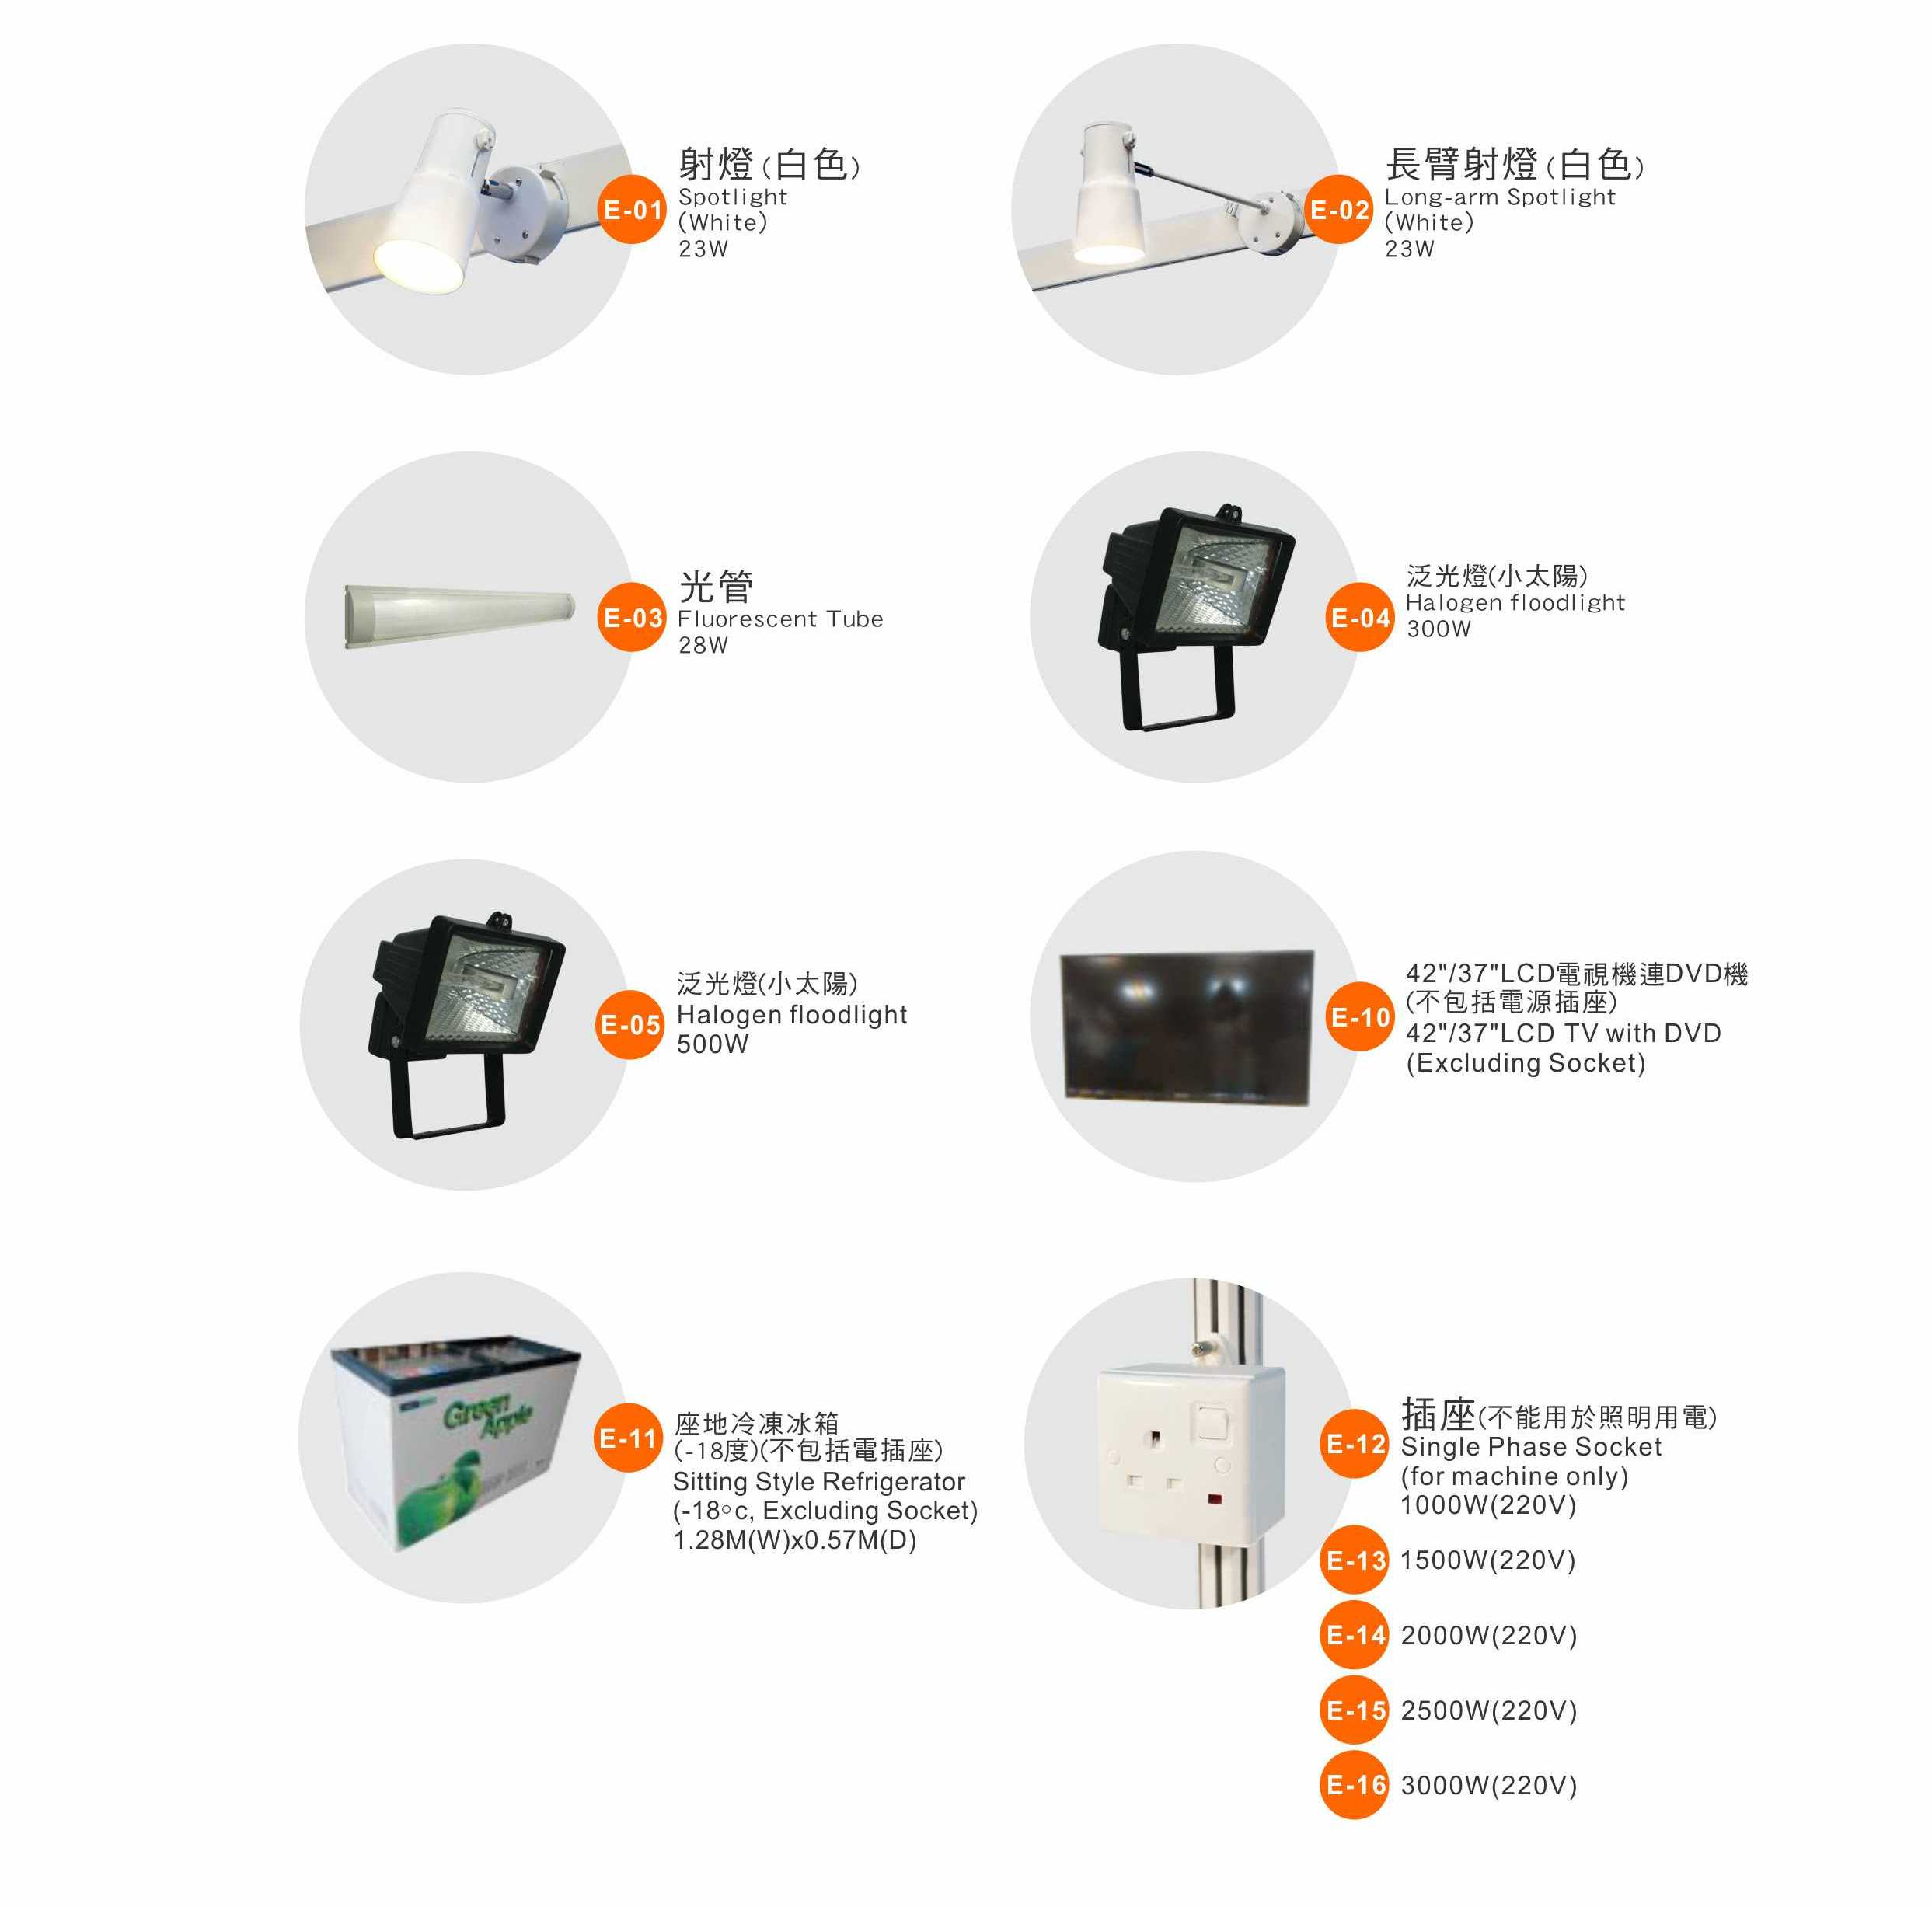

Remark: Each electric socket shall be used for one electrical appliance only. Use of extension cord is prohibited.

